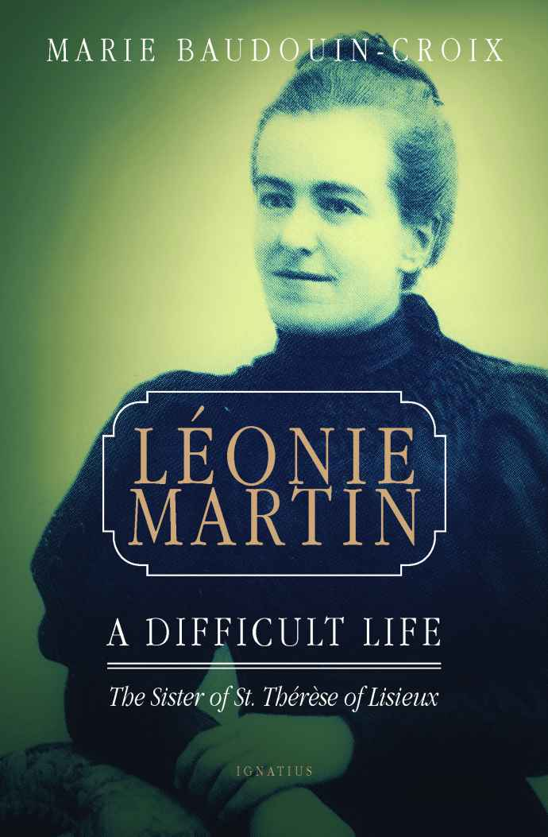

**LÉONIE MARTIN**

**A Difficult Life**

***The Sister of St. Thérèse of Lisieux***

**MARIE BAUDOUIN-CROIX**

**Translated by Mary Frances Mooney**

**Published by Ignatius Press**

**San Francisco, CA**

**Copyright © 2017 by Ignatius Press, CA**

**Transcription of ISBN 978-1-62164-170-4**

**Further reproduction in other than a**

**specialized format is prohibited.**

**Transcribed 2024 in UEB by**

**Terrence McCafferty**

**Xavier Society for the Blind**

**248 West 35th Street, Suite 1502**

**New York, NY 10001**

**In 3 Volumes**

**Volume 3: Chapter 5; Chronological Index**

**Braille pages t1-t4, p1, 1-67**

**Print pages 5,** **135-168**

